

Name: Abdelatef Osama Abdelatef Torky
DR/Mohamed Abdelhamed
Report 1 => Static Route IP

Objective
To achieve Static Routing Protcol
Tools
Cisco Packet Tracker
eNSP
SetUp
Cisco Packet Tracker
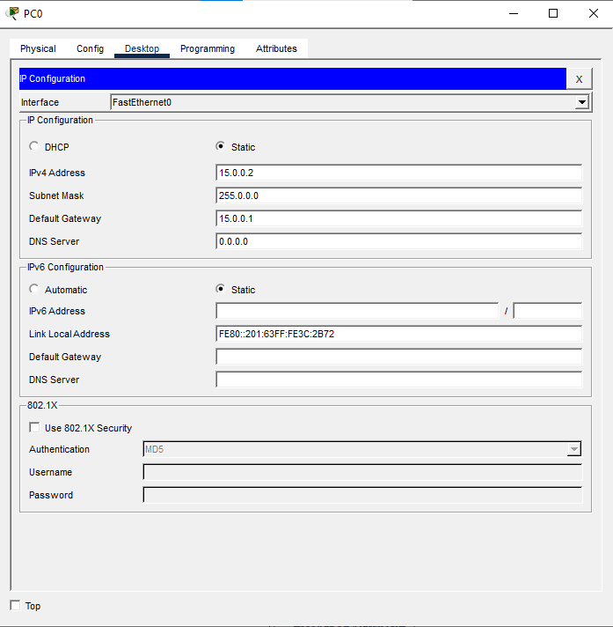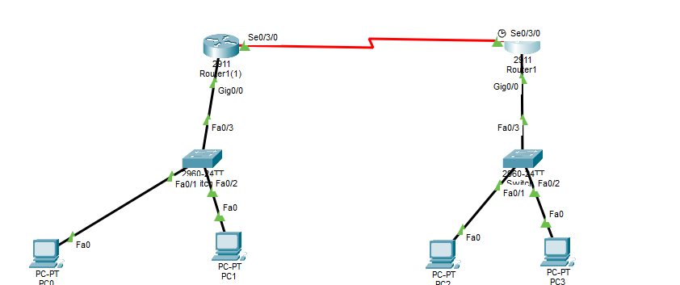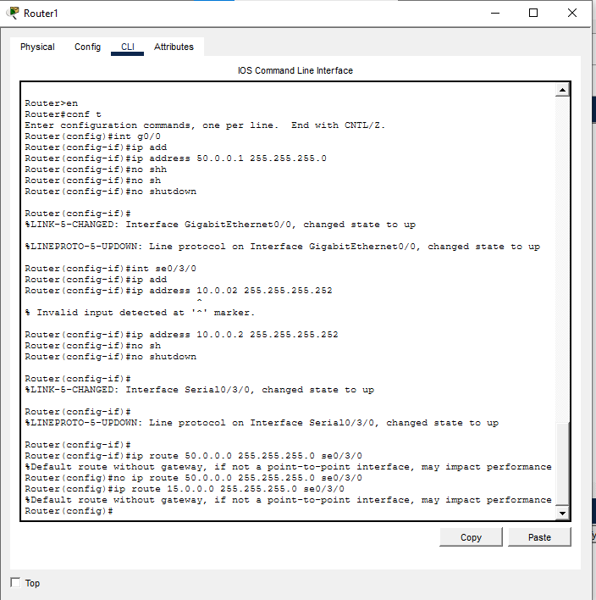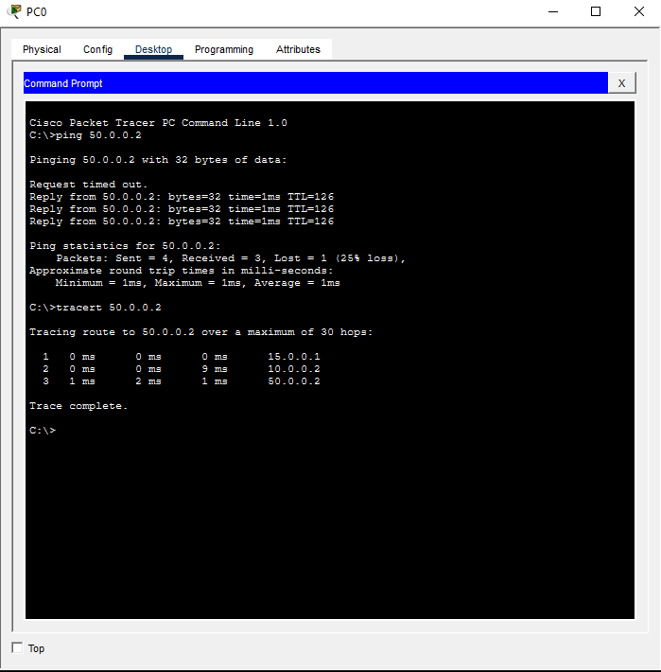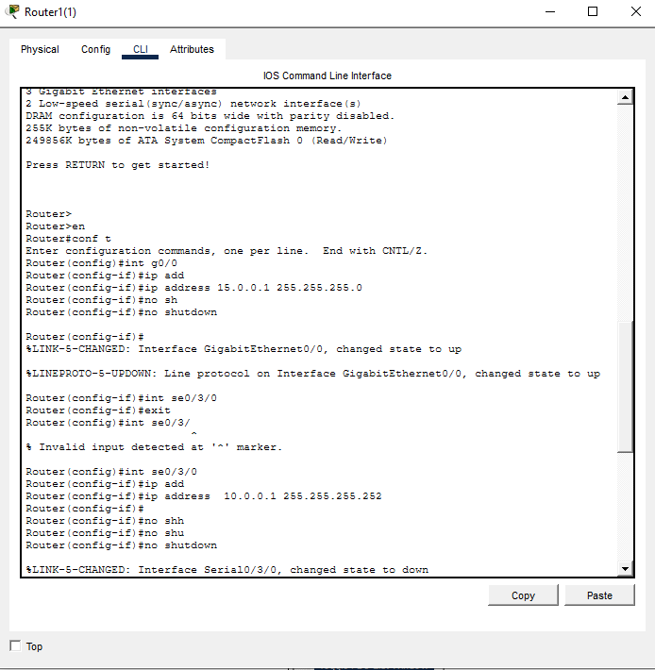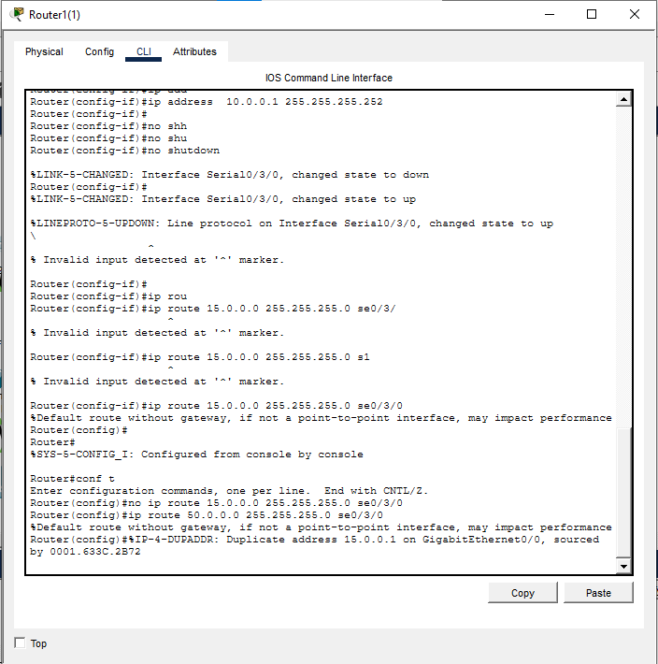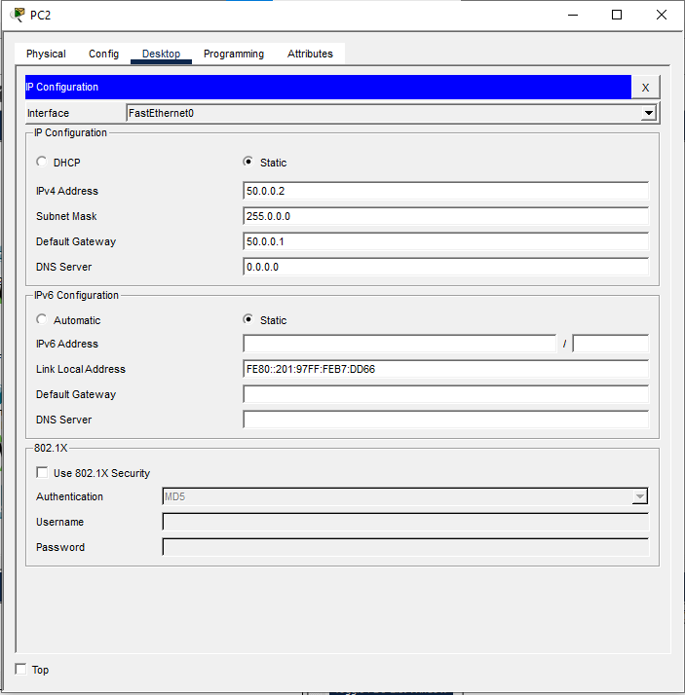

eNSP
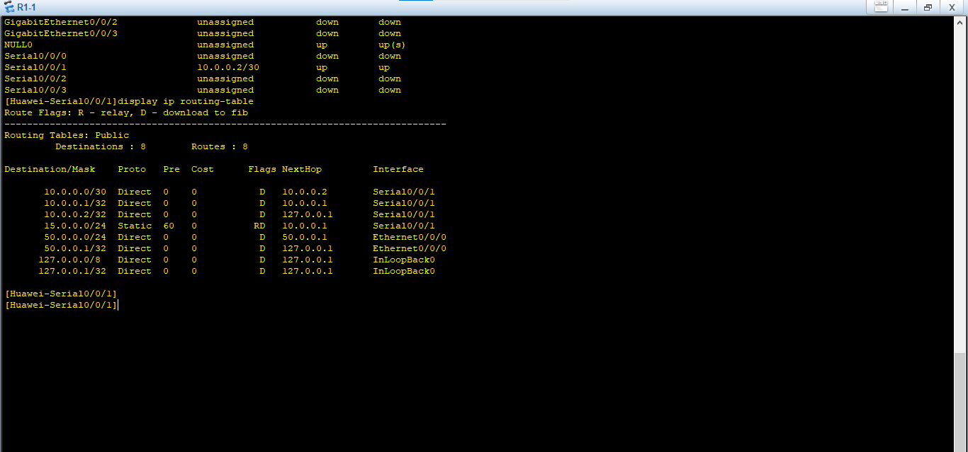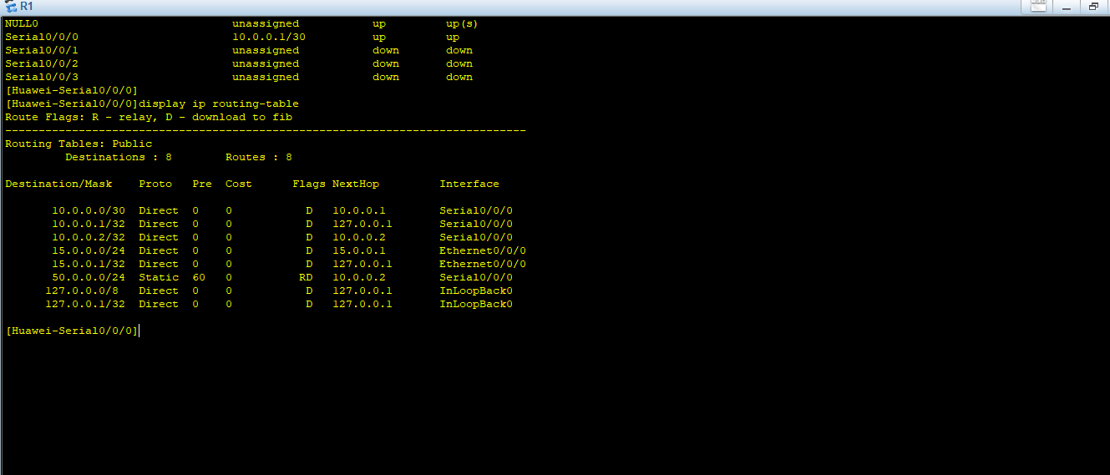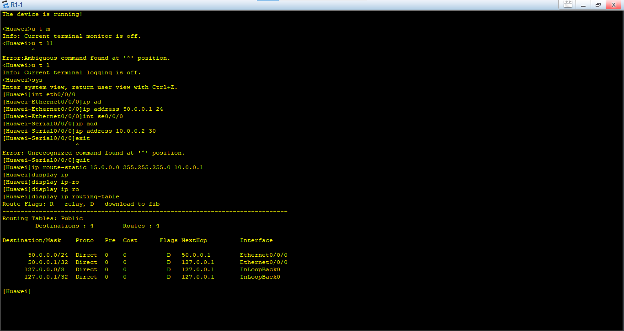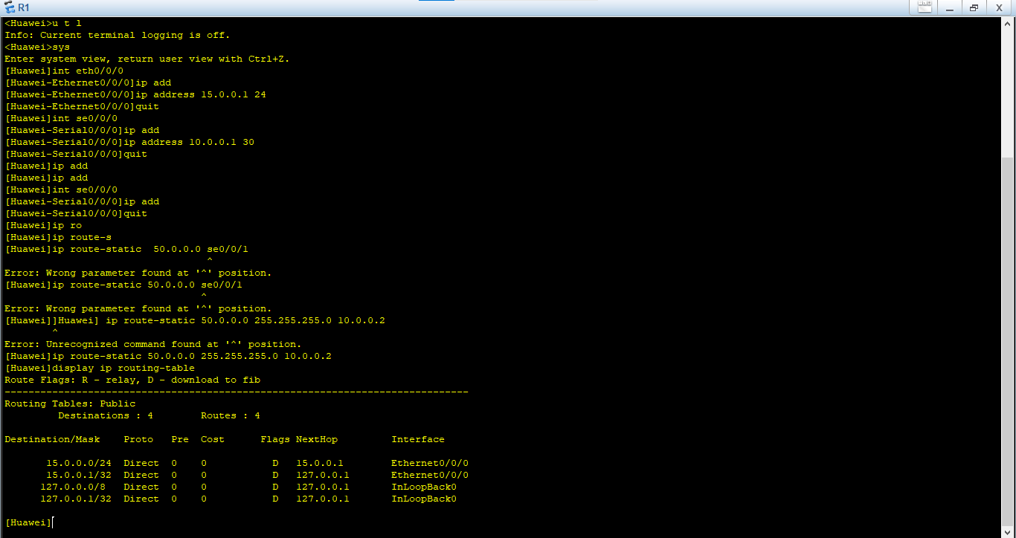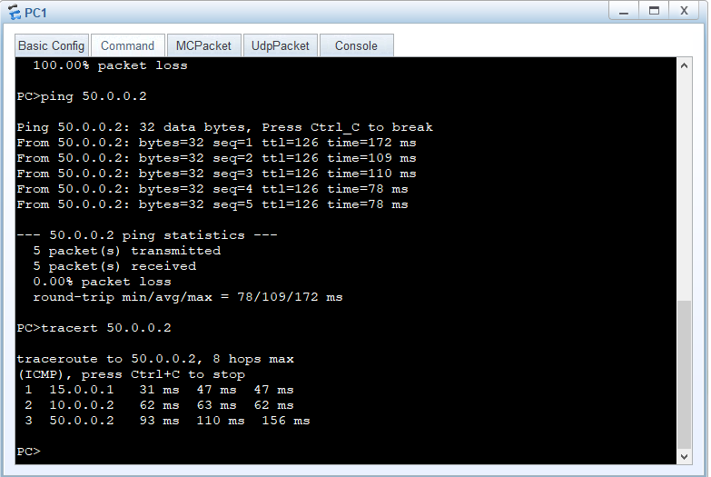

Conclusion
Static routing is a simple and secure method used to manually define network paths in routers. It is suitable for small networks or specific routing scenarios, but it is not efficient for large or dynamic networks because it requires manual updates whenever network topology changes. Therefore, static routing is best used in limited environments or as a backup routing solution.

